**ASSIGNMENT 2 (DQL/DML)**

**Write the following SQL Queries Based on the library database:**

* 1. Get all books with titles containing 'The' followed by any characters.

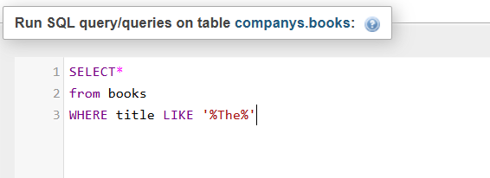

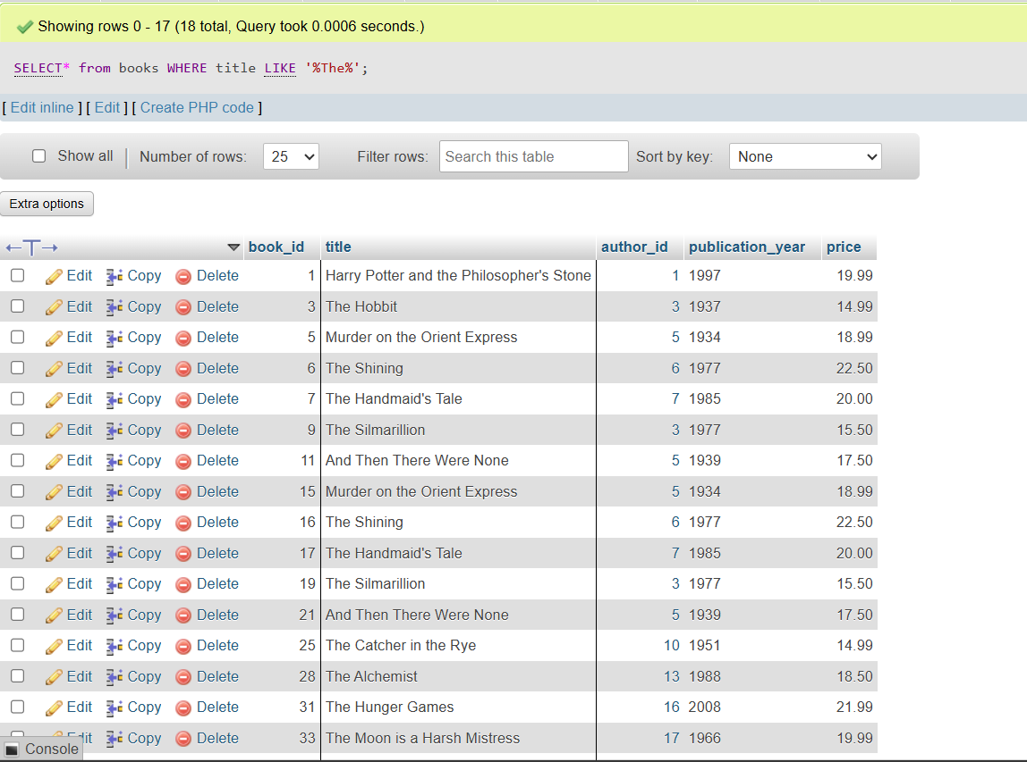

* 1. 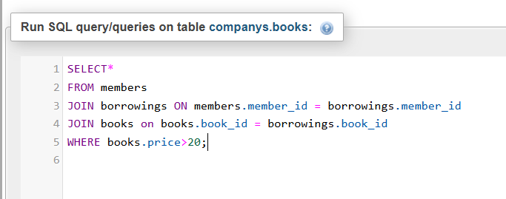List members who have borrowed books with a price higher than $20

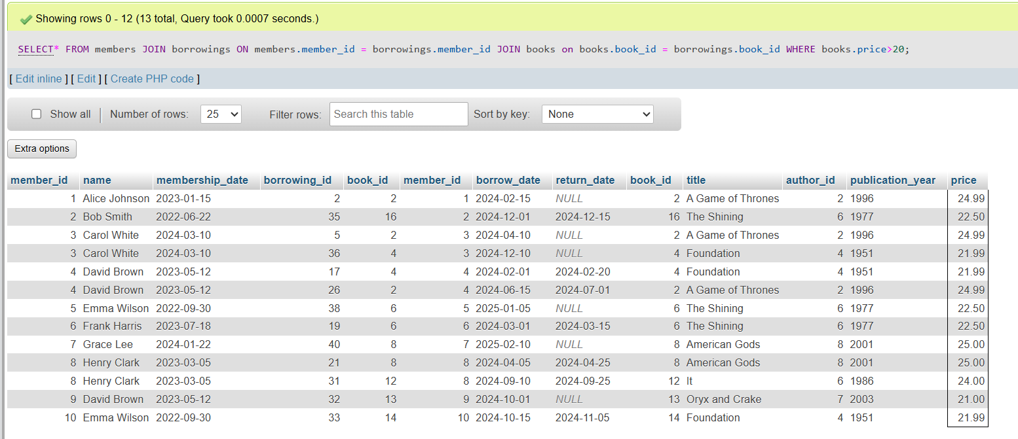

* 1. Find the average price of books for each author, display the author name

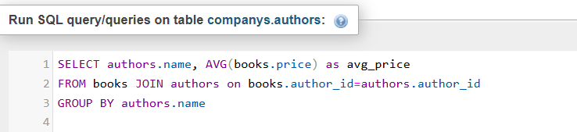

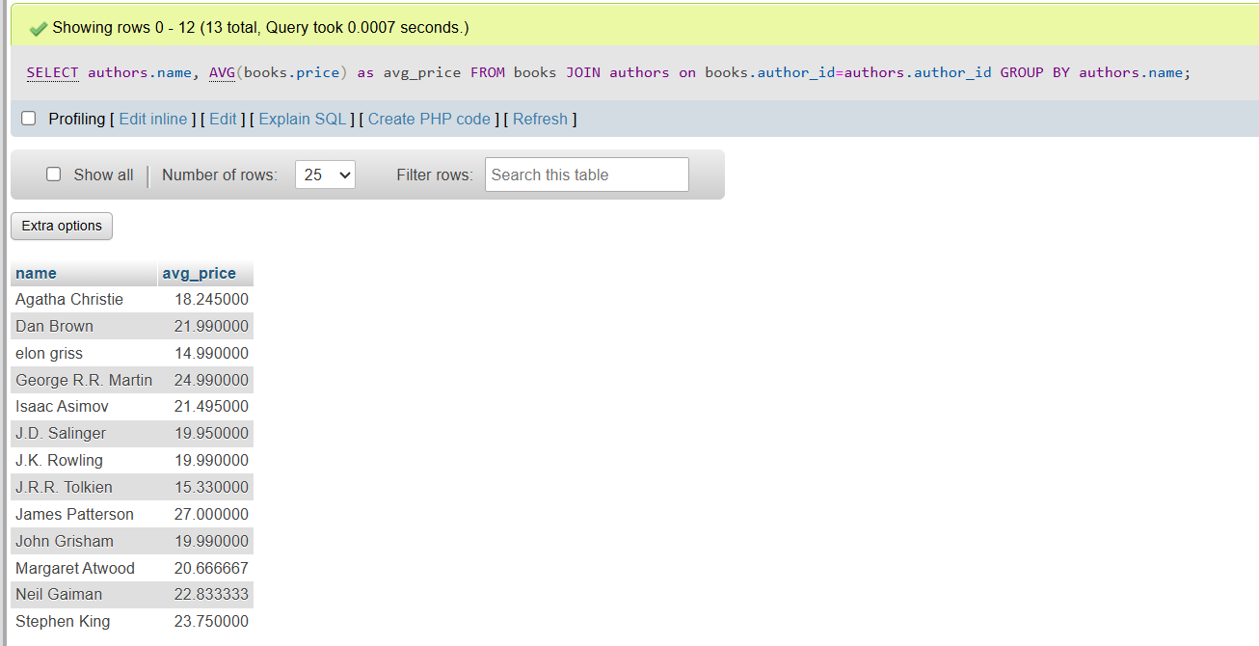

* 1. The number of books each member has borrowed even if they do not borrow any book.

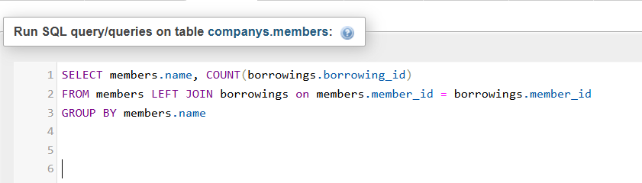

* 1. 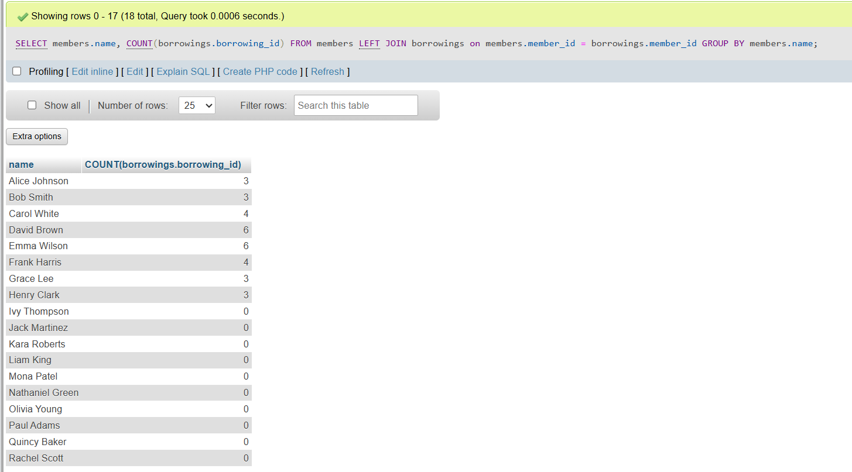Find all books borrowed by members who joined in 2023, display book title, member name and borrow date

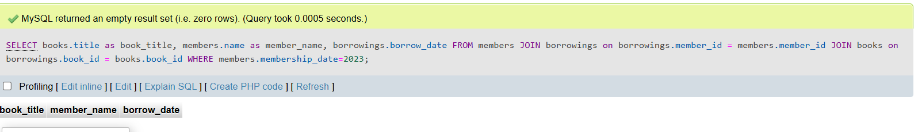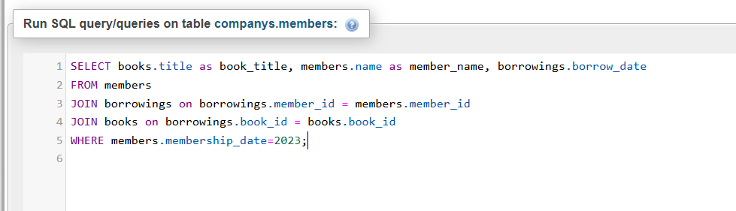

* 1. List authors who have written more than 2 books if their names starts with letter a

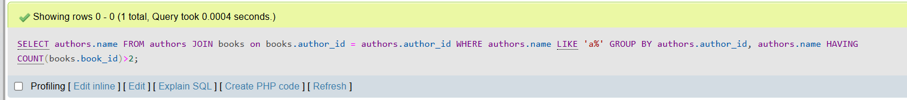

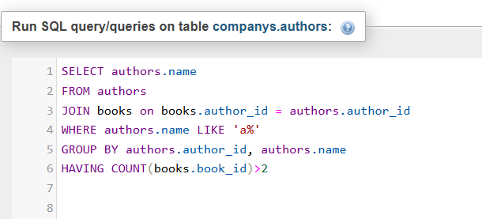

* 1. List all books that have never been borrowed.

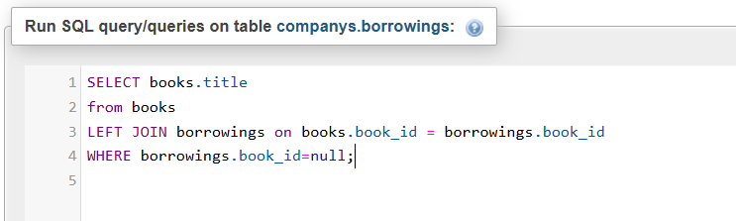

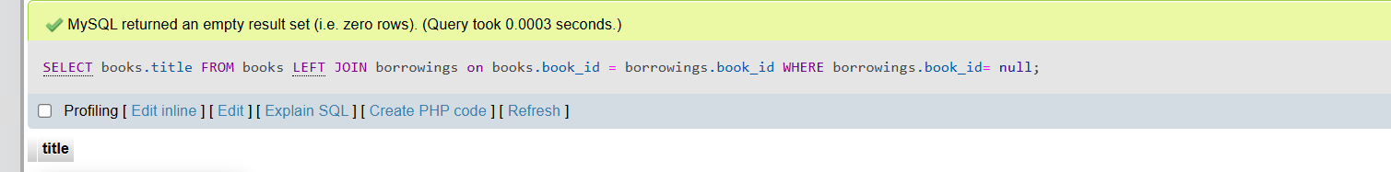

* 1. List all authors who have written books in more than 3 different publication years.

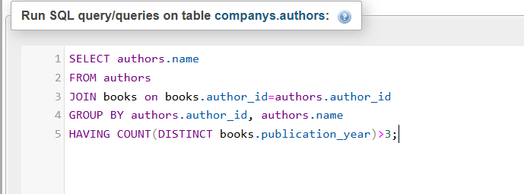

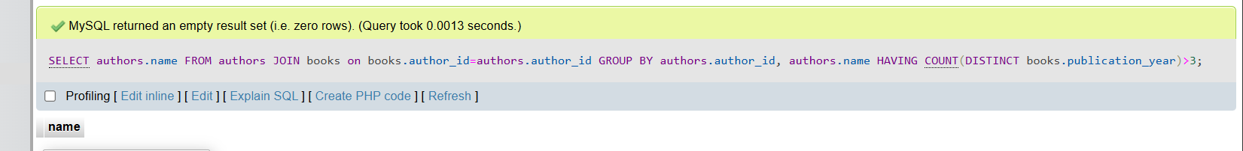

* 1. 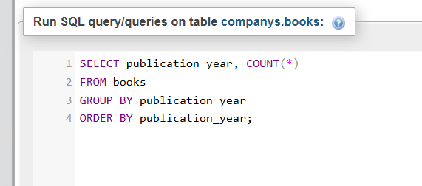Find the total number of books published each year.

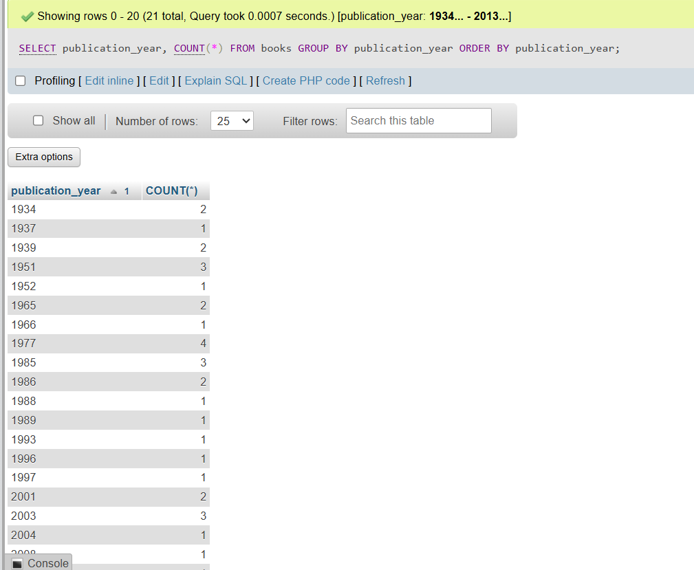

* 1. Find the members who have borrowed books from at least three different authors.

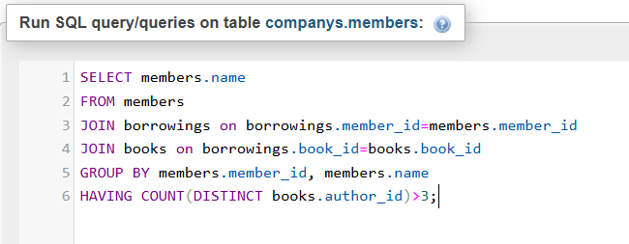

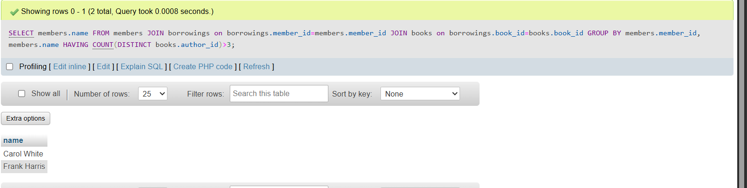

* 1. Increase the price of all books published before 2010 by 10.

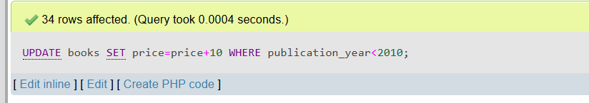

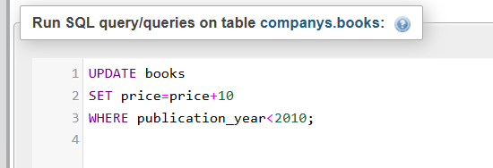

* 1. Change the return date of all borrowings that are still not returned (NULL) to today’s date.

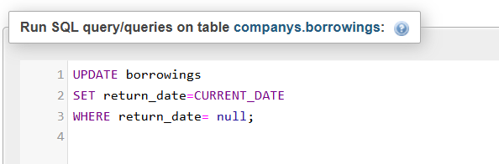

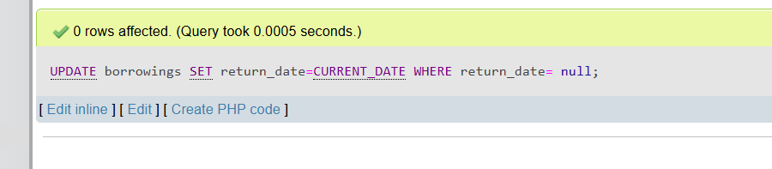

* 1. Update all members who joined before 2020 to have “(Old Member)” added to their name.

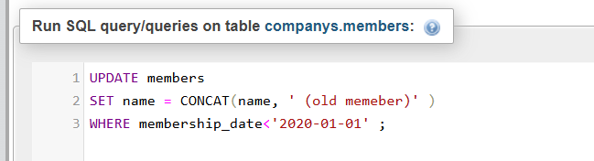

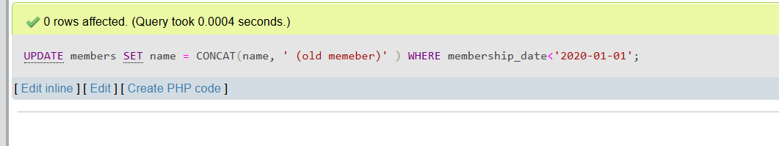

* 1. Increase prices of books written by authors who have published more than 3 books by 15%.

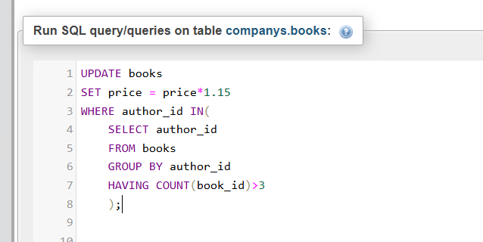

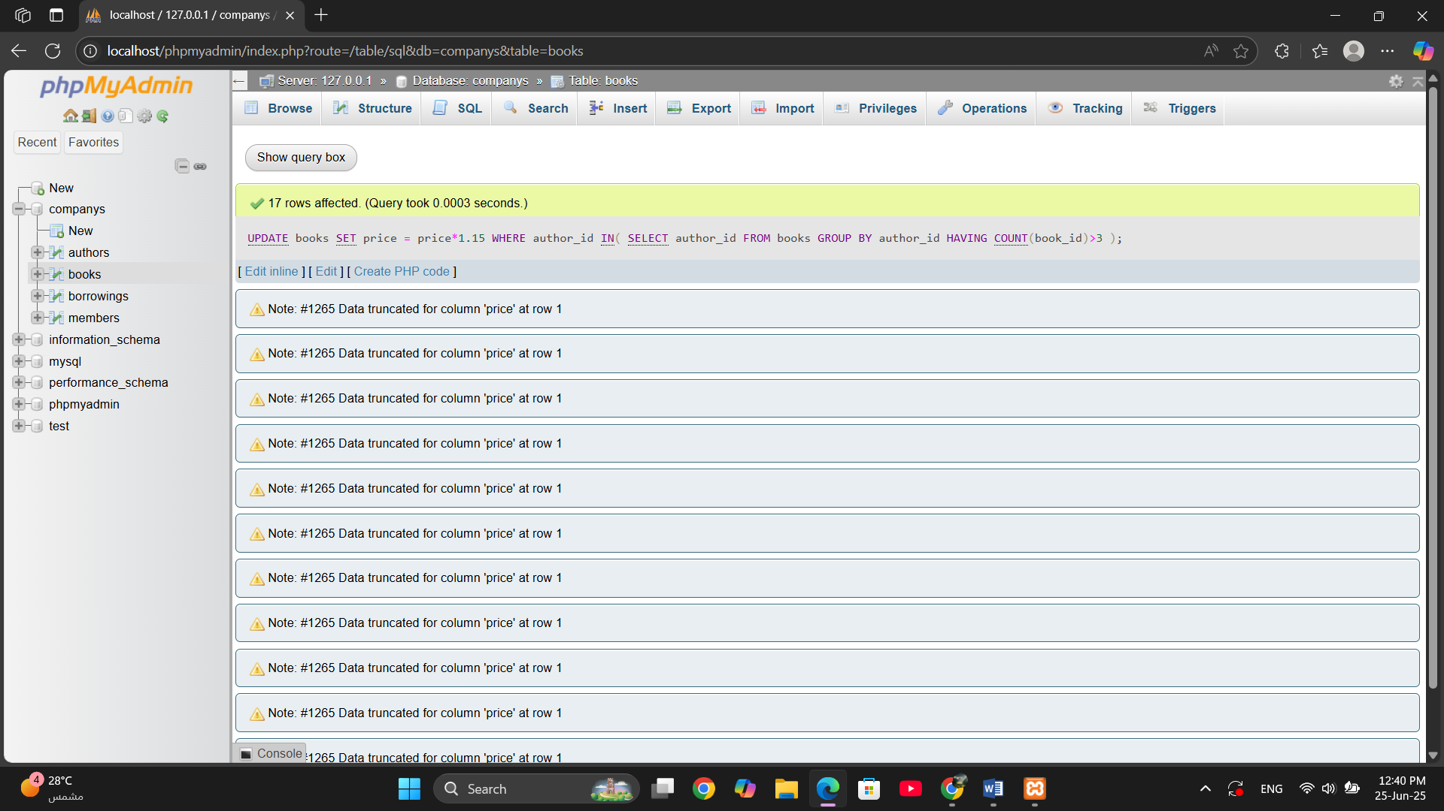

* 1. Set the price of all books written by authors born before 1960 to 50.

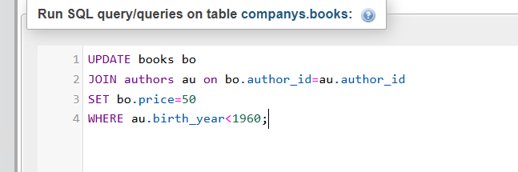

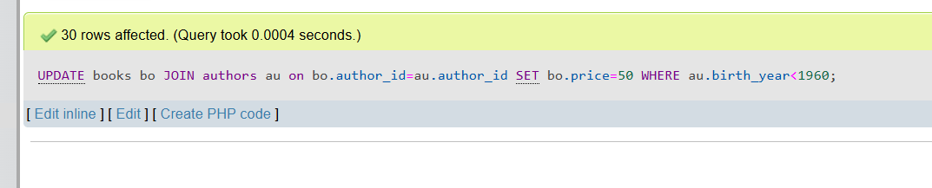

* 1. Give a 20% discount on all books that cost more than 100.

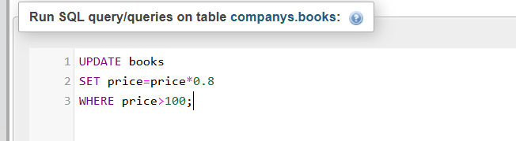

* 1. Delete all borrow records where the book has not been returned.

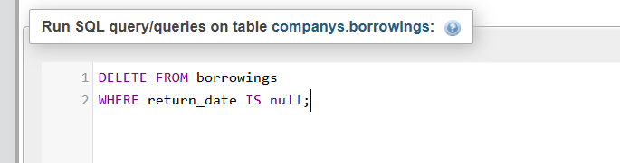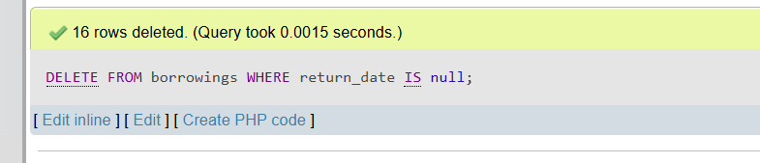

* 1. Delete members who haven’t borrowed any books.

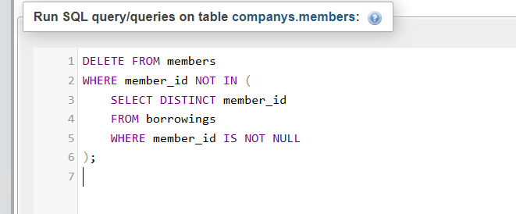

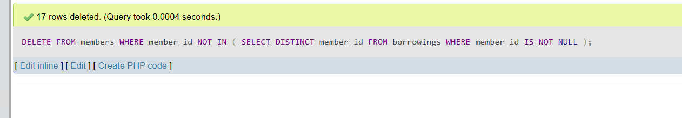

* 1. Delete authors whose books have never been borrowed.

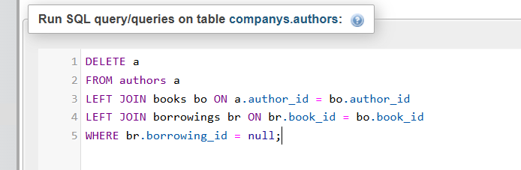

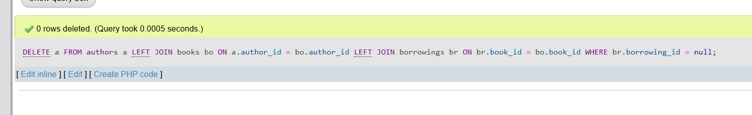

* 1. Delete all members who borrowed only books priced below $10.

